Department of Electrical and computer Engineering

Part IV Research Project

Project Report

Project Number:
[Title of Report]

[Names of the author]
[Name of the project partner]
[Name of project supervisor(s)]

[Date including year DD/MM/YYYY]

Declaration of Originality

This report is my own unaided work and was not copied from nor written in collaboration with any other person.

Name: [Report’s author name here]

ABSTRACT: This is a layout specification and template definition for the report of the Literature Review and Statement of Research Intent report Department students. This template has been generated for producing conference like proceedings for the students’ reports in an electronic form. The format essentially follows the one used for IEEE ICASSP and INTERSPEECH conferences.

Introduction
This template can be found on Canvas. Please use either MS-Word® format file when preparing your submission. The depicted guidelines include complete descriptions of the fonts, spacing, and related information for producing your manuscripts. Please follow them and if you have any questions, direct them to the final year research projects committee.

Page layout and style
The page layout should match with the following rules. A highly recommended way to meet these requirements is to use a given template (Word®) and check details against the corresponding example file.

Basic layout features
- The proceedings of the Project Report will be printed in A4 format. All printed material, including text, illustrations, and charts, must be kept within a print area of 165 mm wide by 226 mm high. Do not write or print anything outside the print area. Text must be fully justified.
- Two columns are used except for the title part and possibly for large figures that need a full-page width.
- Left margin is 20 mm.
- Column width is 80 mm.
- Spacing between columns is 10 mm.
- Top margin 25 mm (except first page 30 mm to title top).
- Text height (without headers and footers) is maximum 235 mm.
- Headers and footers should be left empty.
- Check indentations and spacing by comparing to this example file (in PDF).

Headings
Section headings are centered in boldface with the first word capitalized and the rest of the heading in lower case (sentence case). Sub- headings appear like major headings, except they start at the left margin in the column. Sub-sub-headings appear like sub-headings, except they are in italics and not boldface. See examples in this file. No more than 3 levels of headings should be used.

Text font
Times or Times Roman font is used for the main text. Recommended font size is 10 points which is also the minimum allowed size. Other font types may be used if needed for special purposes. It is VERY IMPORTANT that while making the final PDF file, you embed all used fonts!
LaTeX users: users should use Adobe Type 1 fonts such as Times or Times Roman. These are used by this template.

Illustrations, graphs, and photographs
All figures should be centered on the column (or page, if the figure spans both columns). Figure captions should follow each figure and have the format given in Fig. 1.
Figures should be preferably line drawings. If they contain gray levels or colors, they should be checked to print well on a high-quality non-color laser printer.
Graphics (ie, illustrations, figures) must not use stipple fill patterns because they will not reproduce properly in Acrobat PDF. Please use only SOLID FILL COLOURS.
Figures which span 2 columns (ie occupy full page width) should be placed at the top or bottom of the page.

Tables
An example of a table is shown as Table 1. Somewhat different styles are allowed according to the type and purpose of the table. The caption text may be above or below the table.

Equations
Equations should be placed on separate lines and numbered. Examples of equations are given below. Particularly,
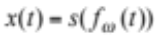 (1)
where 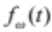 is a special warping function
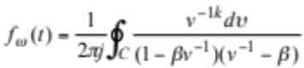 (2)
Table 1: This is an example of a table
Ratio | Decibels
1/1 | 0
2/1 | ≈ 6
3.16 | 10
1/10 | 20
10/1 | -20
100/1 | 40
1000/1 | 60
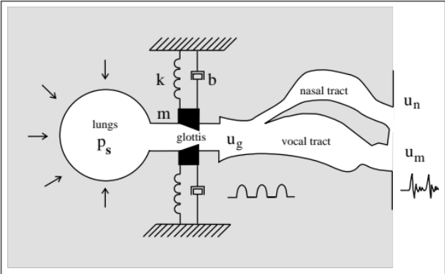
Figure 1: Schematic diagram of speech production.
A residue theorem states that
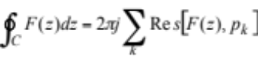 (3)
Applying theorem 3 to 1, it is quite straightforward to see that
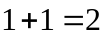! (4)
Finally we have proven the secret theorem of all speech sciences. No more maths is needed to show how useful the result is!!

Hyperlinks
Hyperlinks can be included in your report, if written in full, eg. "http://www.foo.com/index.html". The link text must be all black. Please make sure that they present no problems in printing to paper.

Page Numbers
Page numbers needed to be indicated at the right lower corner of each page excluding the first page of the report. Do not include page numbers in the title and declaration pages. Please don't make any footers or headers!

References
The reference format is the standard IEEE one. References must be numbered in order of appearance, for example [1], [2] and [3]. For proper citation and references listing it is highly recommended to use EndNote and RefWorks software for MSWords and JabRef for Latex format files.

Student affiliation
Please use the same affiliation format in this sample report.

Submitted files
Students are requested to submit PDF files of their manuscripts. The PDF file should comply with the following requirements: (a) there must be no PASSWORD protection on the PDF file at all; (b) all fonts must be embedded; and (c) the file must be text searchable (do CTRL-F and try to find a common word such as 'the').

Discussions
This is the discussions and results if any. Is there any discussion? Then this is the discussion. Is there any discussion. This is the discussion.

Conclusions
This template can be found and downloaded from Canvas.

Acknowledgements
The student would like to thank the supervisor Gerard Hanson and the sponsoring company ‘Intelligent Automation’ for providing the support and guidelines to make this project successful.

References
- Smith, J. O. and Abel, J. S., ``Bark and ERB Bilinear Transforms'', IEEE Trans. Speech and Audio Proc., Vol. 7, No. 6, pp:697-708, 1999.
- Lee, K.-F., Automatic Speech Recognition: The Development of the SPHINX SYSTEM, Kluwer Academic Publishers, Boston, 1989.
- Rudnicky, A. I., Polifroni, Thayer, E H., and Brennan, R. A. "Interactive problem solving with speech", J. Acoust. Soc. Amer., Vol. 84, p S213(A), 1988.

Appendix A
Students may introduce here a proof of a formula used in the report, a piece of software code, additional graphs, template of a schematic diagram, and any other information that might be helpful in describing the topic under investigation. This section is not mandatory and it may not be needed in many of the reports. On the other hand, certain reports may require more than one appendix to clarify the topic.

